**Experiment No.: 1 Date : 28-10-2022**

**Aim:** To read a file content and store it into a list.

**CO5:** Create files and form regular expressions for effective search operations on strings and files.

**Procedure:**

# program to read file content and store it into a list.

# using readlines()

open_file = open("test.txt", 'r')

file_lines = open_file.readlines()

print("File contents: ")

print(file_lines)

open_file.close()

**Output Screenshot**

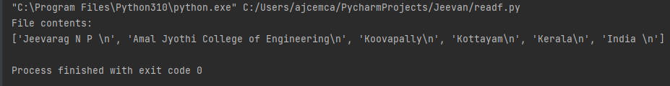

**Result**

The program was executed and the result was successfully obtained. Thus, CO5 was obtained.

**Experiment No.: 2 Date : 28-10-2022**

**Aim:** To read a file content and store it into a list using strip().

**CO5:** Create files and form regular expressions for effective search operations on strings and files.

**Procedure:**

# program to read file content and store it into a list.

# using readlines()

open_file = open("test.txt", 'r')

file_lines = open_file.readlines()

# print without strip

print("File contents with newline character: ")

print(file_lines)

# print with strip

print("\nFile content without newline character: ")

file_lines = [x.strip() for x in file_lines]

print(file_lines)

open_file.close()

**Output Screenshot**

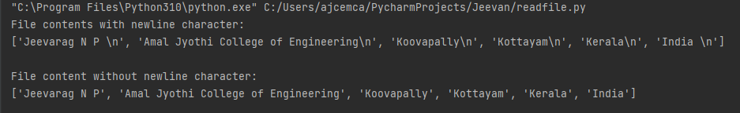

**Result**

The program was executed and the result was successfully obtained. Thus, CO5 was obtained.

**Experiment No.: 3 Date : 28-10-2022**

**Aim:** Python program to copy odd lines of one file to another.

**CO5:** Create files and form regular expressions for effective search operations on strings and files.

**Procedure:**

# program to copy odd lines of one file to another.

# opening files for reading and writing data.

input_file = open('Data.txt')

output_file = open('WriteData.txt', 'w')

# copying/reading from read file to copy_data

copy_data = input_file.readlines()

print("\nActual file content is :")

print([x.strip() for x in copy_data])

for i in range(0, len(copy_data)):

if i % 2 == 0:

output_file.write(copy_data[i])

else:

pass

# Closing file after writing

output_file.close()

# opening write file in read mode and printing values

output_file = open('WriteData.txt', 'r')

print("\nOdd lines are:")

print(output_file.read())

# closing files

input_file.close()

output_file.close()

**Output Screenshot**

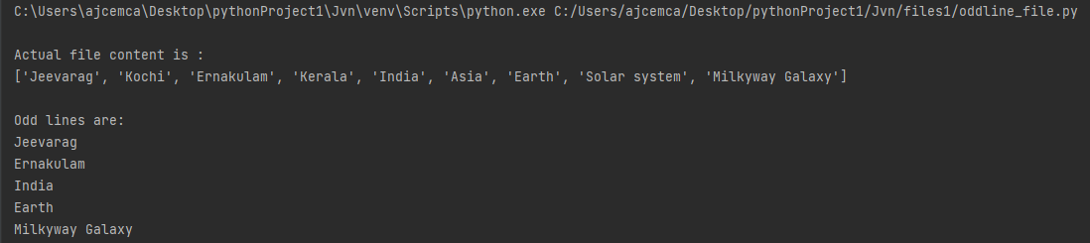

**Result**

The program was executed and the result was successfully obtained. Thus, CO5 was obtained.

**Experiment No.: 3 Date : 28-10-2022**

**Aim:** Python program to copy odd lines of one file to another.

**CO5:** Create files and form regular expressions for effective search operations on strings and files.

**Procedure:**

# program to copy odd lines of one file to another.

# opening files for reading and writing data.

input_file = open('Data.txt')

output_file = open('WriteData.txt', 'w')

# copying/reading from read file to copy_data

copy_data = input_file.readlines()

print("\nActual file content is :")

print([x.strip() for x in copy_data])

for i in range(0, len(copy_data)):

if i % 2 == 0:

output_file.write(copy_data[i])

else:

pass

# Closing file after writing

output_file.close()

# opening write file in read mode and printing values

output_file = open('WriteData.txt', 'r')

print("\nOdd lines are:")

print(output_file.read())

# closing files

input_file.close()

output_file.close()

**Output Screenshot**



**Result**

The program was executed and the result was successfully obtained. Thus, CO5 was obtained.

**Experiment No.: 4 Date : 28-10-2022**

**Aim:** Write a Python program to read each row from a given csv file and print a list of strings.

**CO5:** Create files and form regular expressions for effective search operations on strings and files.

**Procedure:**

import csv

# Open the csv file

with open('datas1.csv', 'r') as file:

# Create a CSV reader

reader = csv.reader(file)

# iterate over the rows of the CSV file

for row in reader:

# print the row as a list of strings

print(row)

**Output Screenshot**

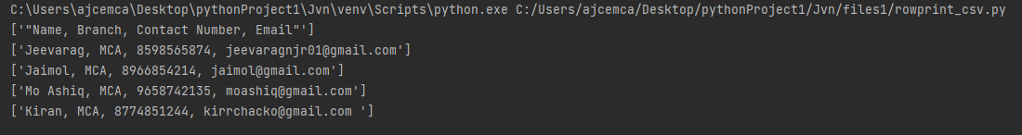

**Result**

The program was executed and the result was successfully obtained. Thus, CO5 was obtained.

**Experiment No.: 5 Date : 28-10-2022**

**Aim:** Write a Python program to read specific columns of a given CSV file and print the content of the columns.

**CO5:** Create files and form regular expressions for effective search operations on strings and files.

**Procedure:**

import csv

# specify the column indices that you want to read

columns_to_read = [0,2]

# open the CSV file and read the contents

with open('demo.csv', 'r') as file:

clmn_reader = csv.reader(file)

# iterate over the rows of the CSV

for row in clmn_reader:

# print the contents of the specified columns

print([row[i] for i in columns_to_read])

**Output Screenshot**

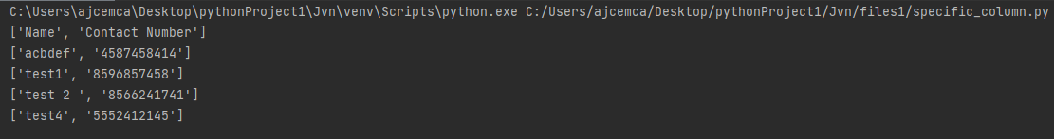

**Result**

The program was executed and the result was successfully obtained. Thus, CO5 was obtained.

**Experiment No.: 3 Date : 28-10-2022**

**Aim:** Write a Python program to write a Python dictionary to a csv file. After writing the CSV file, read the CSV file and display the content.

**CO5:** Create files and form regular expressions for effective search operations on strings and files.

**Procedure:**

# Write a python program to write a python dictionary to a CSV file.

# After writing the CSV file read and display the content.

import csv

# Data to be inserted

data = [{'Name': 'Jeevan', 'Age': '21', 'Country': 'India'},

{'Name': 'Ashiq', 'Age': '22', 'Country': 'India'},

{'Name': 'Kiran', 'Age': '23', 'Country':'India'}]

# Write to CSV file

with open('people.csv', 'w') as csvfile:

headernames = ['Name', 'Age', 'Country']

csvwriter = csv.DictWriter(csvfile, fieldnames=headernames)

csvwriter.writeheader()

for row in data:

csvwriter.writerow(row)

# read from CSV file and print contents

with open('people.csv', 'r') as csvfile:

reader = csv.DictReader(csvfile)

for row in reader:

print(row)

**Output Screenshot**



**Result**

The program was executed and the result was successfully obtained. Thus, CO5 was obtained.